Documentation for Laba#7

Zakharchenko Anna

In this document I will describe the functionality of my code and what each function does. At first, I will show the input and output of functions in my code.

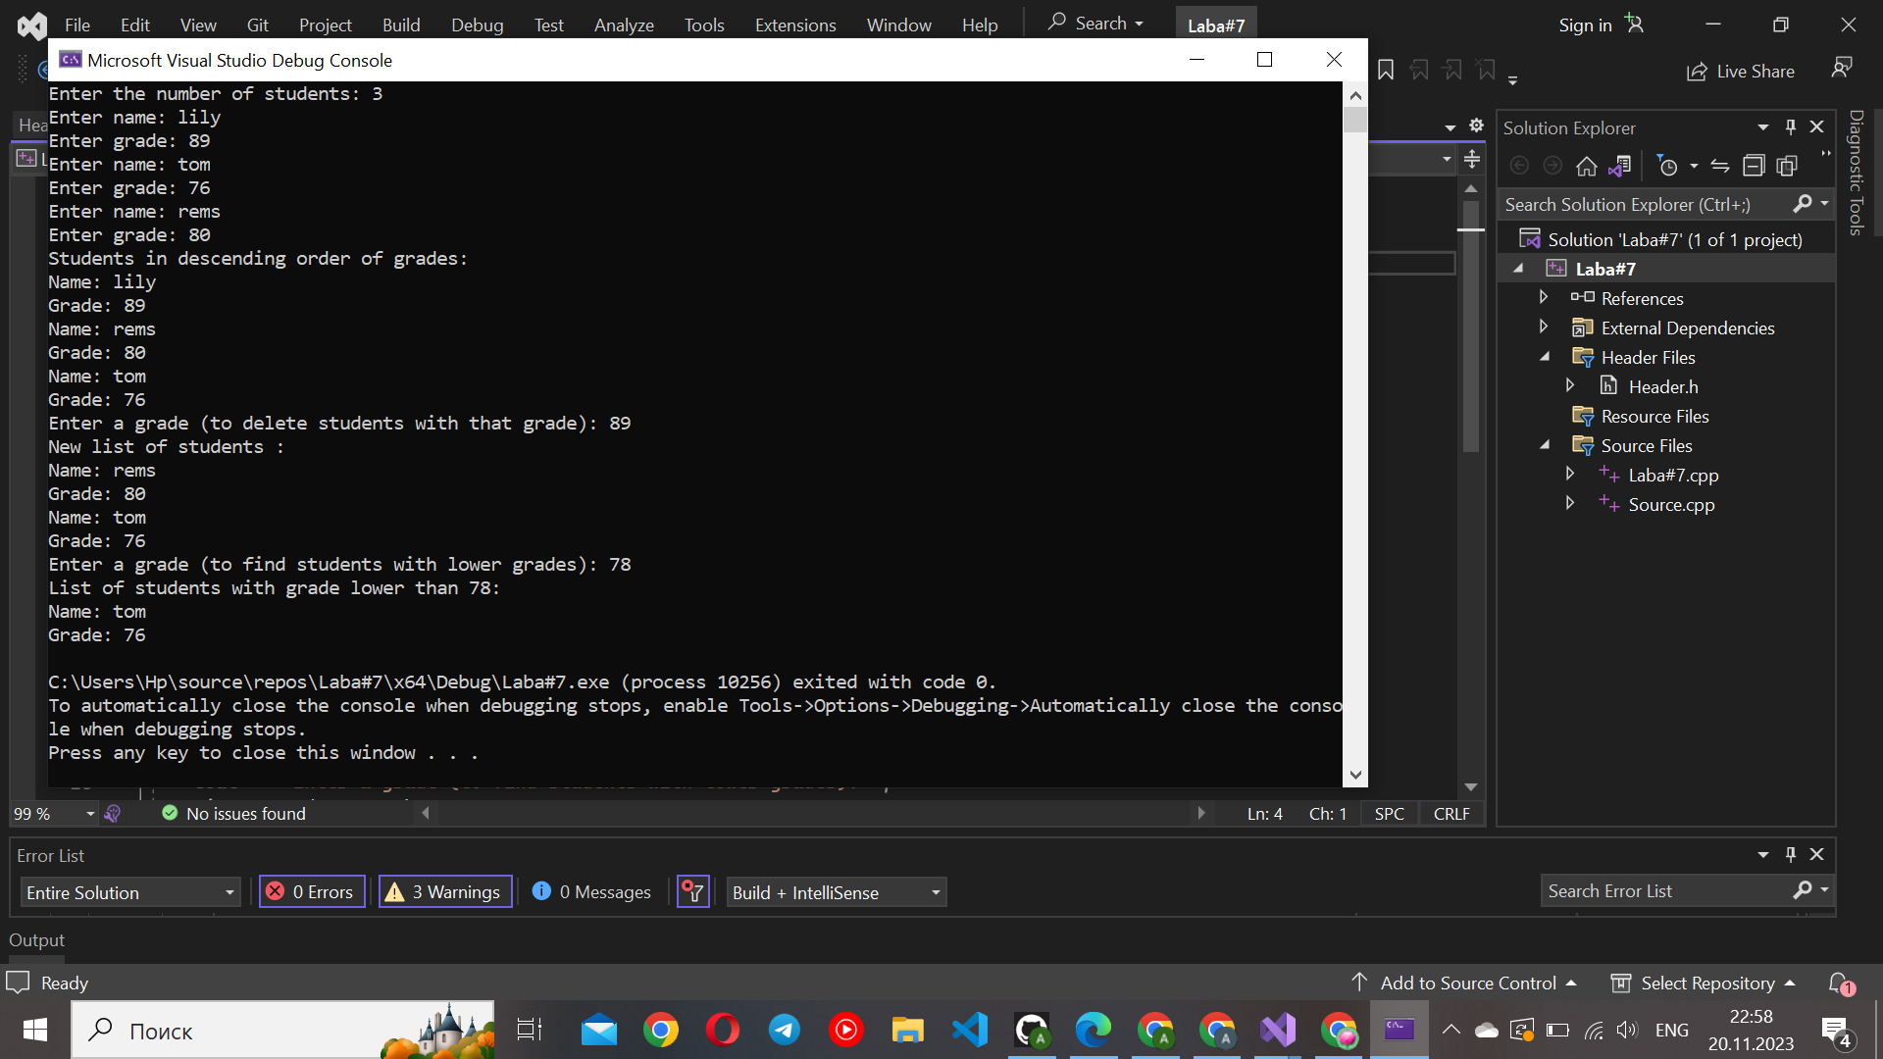

1**) InsertStudent(ptree& tree, Student student):**

This function inserts a new student into a binary search tree based on the student's grade.

It takes the address of the tree (tree) and a Student object as parameters.

If the tree is empty, it creates a new node for the student and assigns it as the root.

If the student's grade is greater than the grade of the current node, it recursively inserts the student into the right subtree; otherwise, it inserts into the left subtree.

2) **FindMinStudent(ptree tree):**

This function finds the node with the minimum grade in a binary search tree.

It takes the root of the tree as a parameter.

It iteratively traverses the left subtrees until it reaches the leftmost leaf, which contains the minimum grade.

3) **DeleteStudent(ptree& tree, double grade):**

This function deletes a student with a specified grade from the binary search tree.

It takes the address of the tree (tree) and the grade of the student to be deleted as parameters.

It uses recursive calls to find and delete the node containing the student with the specified grade.

If the student has two children, it finds the minimum student in the right subtree and replaces the student to be deleted with this minimum student.

4**) InOrder(ptree tree):**

This function performs an in-order traversal of the binary search tree.

It takes the root of the tree as a parameter.

It prints the information of each student node (name and grade) in ascending order of grades.

5**) FindStudentWithLowerGrade(ptree tree, double grade):**

This function finds and prints information about students in the binary search tree with grades lower than a specified grade.

It takes the root of the tree and the specified grade as parameters.

It performs an in-order traversal and prints information for nodes whose grades are lower than the specified grade.

6**) AddStudent(ptree& tree):**

This function allows the user to input information for multiple students and adds them to the binary search tree.

It takes the address of the tree (tree) as a parameter.

It prompts the user to enter the number of students and then iteratively takes input for each student's name and grade, creating a Student object and inserting it into the tree using InsertStudent.